Assignment 8 (October 31 – November 7)

1. The supply function of a certain commodity is: Q = a + bP2 + R1/2 (a<0, b>0) [ R: rainfall ].
a) Find the price elasticity of supply and rainfall elasticity of supply.
b) How do the two partial elasticities vary with P and R? In monotonic fashion (assuming positive P and R)?

2. Find all partial derivatives of the first and second order of the composite function 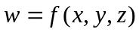, where 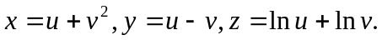

For each of the following functions find the critical points.

3. 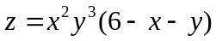

4. 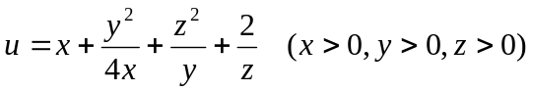
5. Find the critical points (if any) of the implicit function z of variables x and y
.

